**Bank Account Details**

|  |  |
| --- | --- |
| **For Indian Contribution** | |
| **Name of Account holder** | Navchetna Sarvangin Vikas Kendra |
| **Account No.** | 31819125851 |
| **IFSC Code** | **SBIN0011152** |
| **Bank Name** | STATE BANK OF INDIA |
| **Branch** | Kaij Dist. Beed |

**Legal Status of Navchetana Sarvangin Vikas Kendra (NSVK)**

|  |  |
| --- | --- |
| **Particulars** | **Details** |
| **Trust Act Registration Number** | F-14455-Beed Society Act 1860 Maha-247/08 Beed |
| **FCRA Number** | 083770088R |
| **80G (Tax Exemption)** | ITBA/EXM/S/80G/2019-20/1019644895(1) |
| **PAN (Permanent Account Number)** | AACTN0921B |
| **TAN (Tax Deduction Account Number** | NSKN04133D |
| **12A Registration (Tax Exemption)** | 1113/307/2016-17/2526 |
| **NGO Darpan Unique Id** | MH/2018/0205242 |
| **Name of the Contact person** | Ms. Manisha Ghule, Secretary  Phone: 9403732424  Mail ID: [navchetana2008@gmail.com](mailto:navchetana2008@gmail.com) Website: [http://navchetna.org](http://navchetna.org/) |

**Contact**

To know more about

* NSVK, contact Manisha Ghule at [navchetana2008@gmail.com](http://navchetana2008@gmail.com)
* CRP, please reach out to Alekha Choksey at [alekhachoksey@gmail.com](mailto:alekhachoksey@gmail.com)
* Dasra, contact Ethna Ghosh at [ethna@dasra.org](http://ethna@dasra.org)

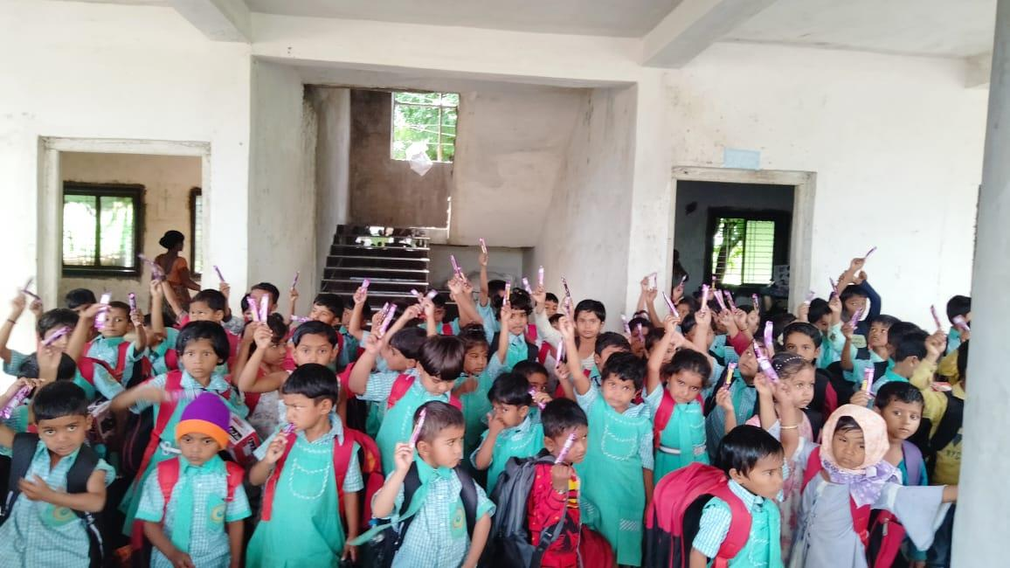

Figure 5 Young students at Navchetana International English School after school hours